
Economics Induction Pack
Edexcel Economics
Summer 2026 Themes 1 and 2

Theme 1 Micro Edexcel Economics
Read and understand the below notes and assess your understanding by attempting ALL the questions that follow.
To further enhance your understanding, you can also: watch videos by Econplusdal on Youtube, and use Economics Online and Tutor2u.com.

1.1.1 Economics as a Social Science
Economists need to make assumptions. A key assumption that is made assuming that events occur with ceteris paribus. This assumption is that other things are being held equal or constant, so nothing else changes. Economists cannot conduct scientific experiments, like in the natural
sciences, so models are devised. Economists then use real-life scenarios to build these models upon, and assumptions are made with the models.
www.pmt.education
1.1.2 Positive and Normative Statements
It is important to be able to distinguish between fact and fiction in current
affairs. Positive statements are objective. They can be tested with factual evidence,
and can consequently be rejected or accepted. Look for words such as ‘will’, ‘is’. For example, “Raising the tax on alcohol will lead to a fall in the demand of alcohol and a fall in the profits of pub landlords” is a positive statement. “Higher temperatures will lead to an increase in the demand for sun cream”
is also a positive statement. The key thing here is that these statements can be tested, the results can be examined and the statement can then be rejected or accepted.
Normative statements are based on value judgements. These are subjective and based on opinion rather than factual evidence. Look for words such as ‘should’, and if the statement is suggesting one action is more credible than another. For example, “The free market is the best way to allocate resources” is a normative statement, because it is based on opinion and suggests one
method of resource allocation is better than another. “The government should increase the tax on alcohol” is another normative statement. Value judgements can influence economic decision making and policy. Different economists may make different judgements from the same statistic.
For example, the rate of inflation can give rise to different conclusions.
1.1.3 The Economic Problem
The basic economic problem is scarcity. Wants are unlimited and resources
are finite, so choices have to be made. Resources have to be used and distributed optimally. For example, if you only have £1 and you go to a shop, you can buy either the chocolate bar or the packet of crisps. The scarcity of the resource (the money) means a choice has to be made between the chocolate and the crisps. This gives rise to opportunity cost. The opportunity cost of a choice is the
value of the next best alternative forgone. In the above example, the opportunity cost of choosing the crisps is the chocolate bar. If a car was bought for £15,000 and after 5 years the value depreciates by
£5,000, the opportunity cost of keeping the car is £5,000 (which could have been gained by selling the car), regardless of the starting price. Opportunity cost is important to economic agents, such as consumers, producers and governments. For example, producers might have to choose between hiring extra staff and investing in a new machine. The government might have to choose between spending more on the NHS and spending more on education. They cannot do both because of finite resources, so a choice has to be made for where resources are best spent.

The factors of production (CELL):
Factor Description Reward/Incentive
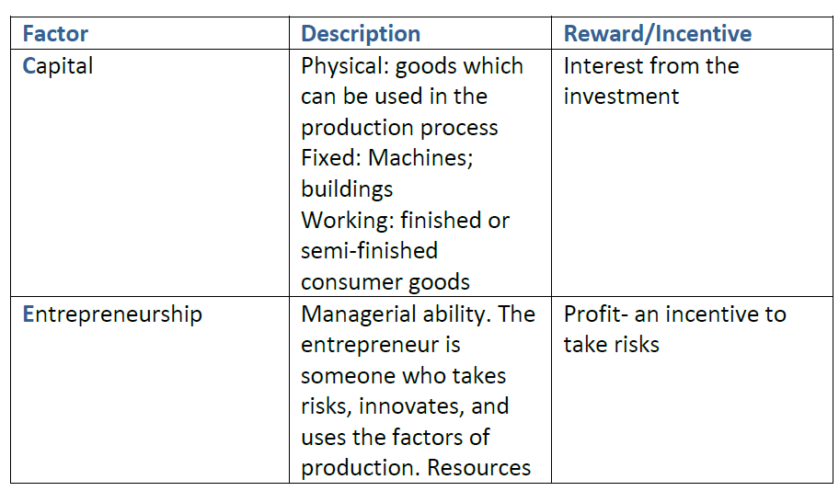
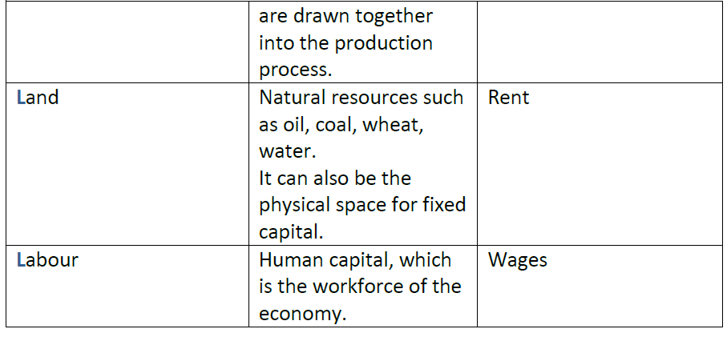
These factors of production are inputs, and they produce outputs in the form of
goods and services. This forms the economy.

Renewable and non-renewable resources:
Renewable resources can be replenished, so the stock level of the resources can be maintained over a period of time. For example, commodities such as oxygen, fish, or solar power are renewable assuming the rate of consumption of the resource is less than the rate of replenishment. If the resource is consumed faster than it is renewed, the stock of the resource will decline over time. This is important in environmental economics, and can be managed by preventing or limiting deforestation, or imposing fishing quotas. Renewable resources are sustainable. However, currently, resources are being consumed faster than the
planet can replace them. The Worldwide Fund for Nature claims that two planets will be required to meet global demand by 2050 if this continues. Non-renewable resources cannot be renewed. For example, things produced from fossil fuels such as coal, oil and natural gas are non-renewable. The stock level decreases over time as it is consumed. Methods such as recycling and finding substitutes, such as wind farms, can reduce the rate of decline of the resource. Production possibility frontiers (PPFs) depict the maximum productive potential of an economy, using a combination of two goods or services, when resources are fully and efficiently employed. PPF curves can show the opportunity cost of using the scarce resources. For example, if the scare resource is milk, there is a trade-off between producing more cheese or more yoghurt from the milk. The PPF can show this:

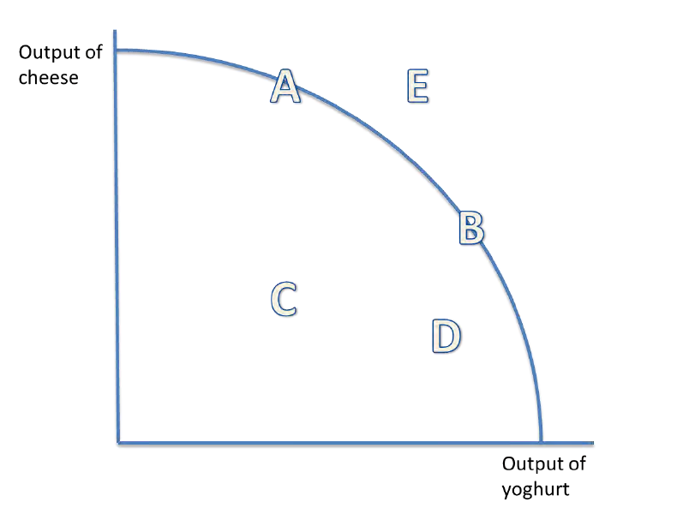

Producing at points A and B are the most efficient combinations of output on the PPF. Producing at B, so more yoghurt than cheese is produced, incurs an opportunity
cost of producing more cheese. The law of diminishing returns states that the opportunity cost of producing more yoghurt increases, in terms of the lost units of cheese that could have been
produced. Producing at C or D is inefficient, and resources are not used to their full productive
potential. There is the potential to use these resources more efficiently, which would shift production closer to the curve. Producing at E is not yet attainable with the current resources.

1.1.4 Production Possibility Frontiers
www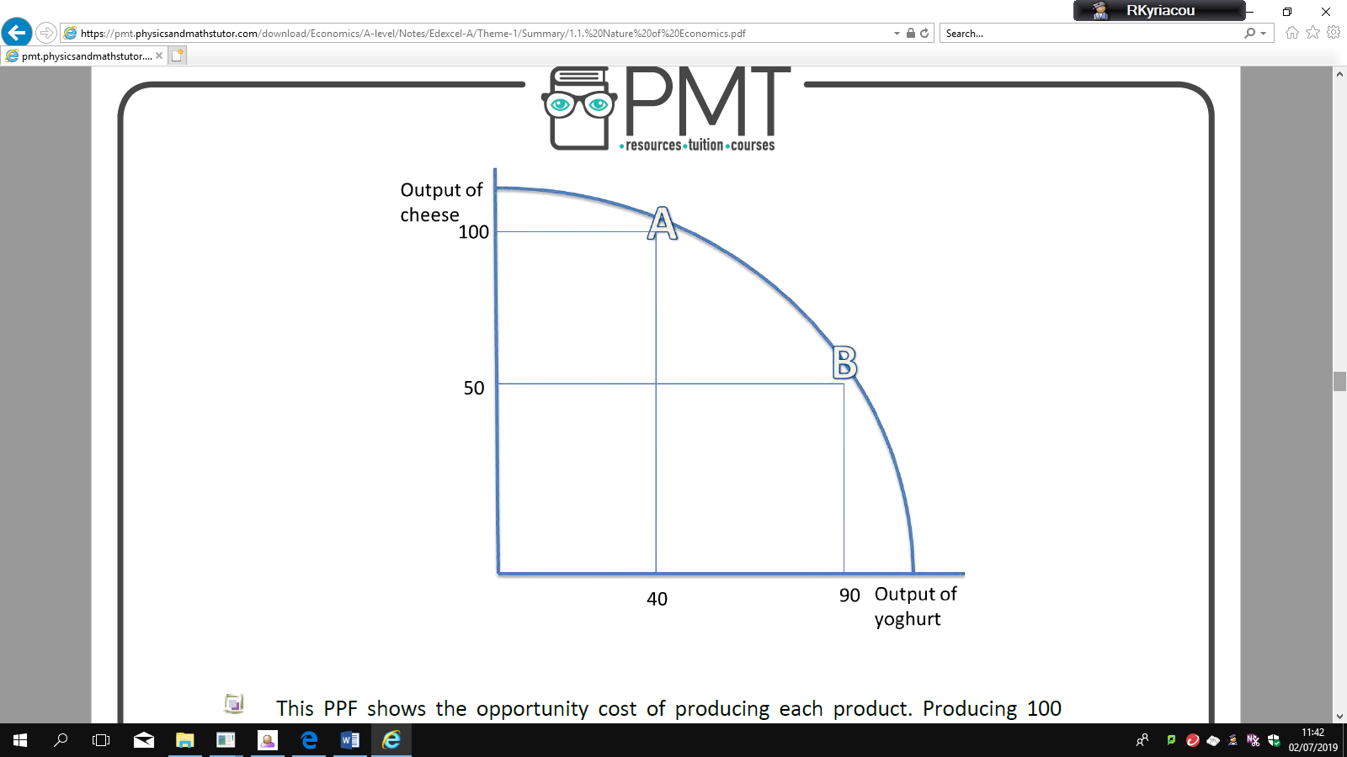.
This PPF shows the opportunity cost of producing each product. Producing 100 units of cheese means that only 40 units of yoghurt can be produced instead of the potential of 90. Therefore, the opportunity cost is 90 - 40 = 50 units of yoghurt.
Economic growth and decline:
The PPF can also depict economic growth or decline. Only production under and on the PPF is attainable. Production outside of the PPF is not obtainable. However, only production on the PPF uses resources efficiently (A and B). It is inefficient to produce below the PPF (point C).
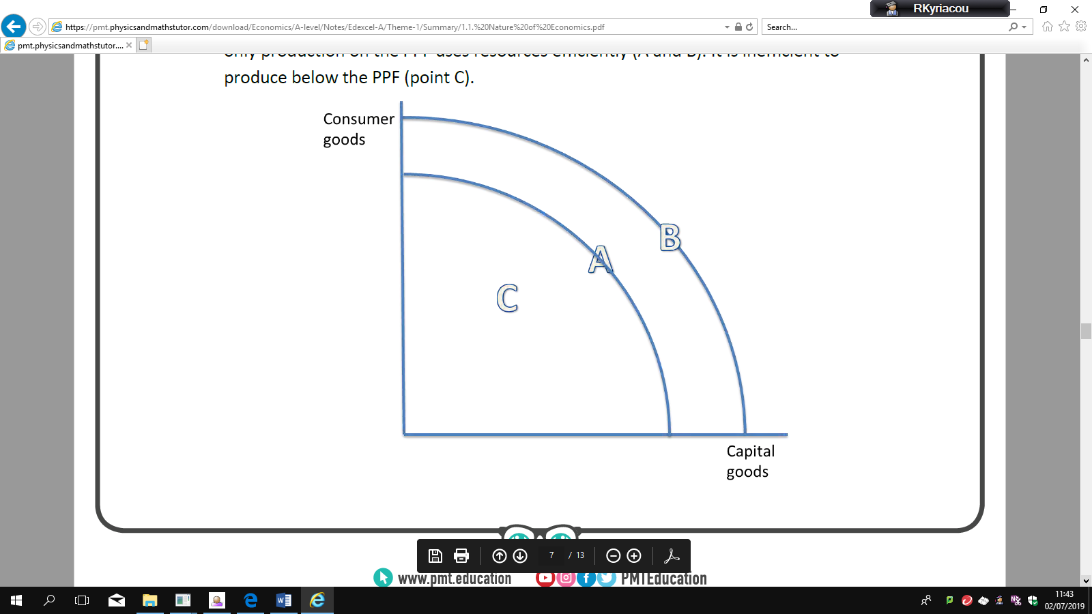

o A fixed amount of resources are used
o There is a constant state of technology

An increase in the quantity or quality of resources shifts the PPF curve outwards, so the productive potential of the economy increases, and there is economic growth. This can be achieved with the use of supply side policies. A PPF curve may shift inwards as a result of a decrease in the quality or quantity of resources in an economy. A country may see their PPF curve shift inwards if they are affected by natural disasters, such as flooding, or if there is brain drain. Moving along the PPF is different to shifting the PPF. Moving along the PPF uses the same number and state of resources, and shifts production from fewer consumer goods to more capital goods, for instance. This incurs an opportunity cost. Shifting the PPF curve outwards, for example, uses either more resources o resources of a greater quality. This reduces the opportunity cost of producing either capital or consumer goods, since more goods can be produced overall.

Capital goods are goods which can be used to produce other goods, such as
machinery.
Consumer goods are goods which cannot be used to produce other goods, such as
clothing.
Tasks:
- Define and provide real life examples of key terms below:
 | Define | Example(s)
Ceteris Paribus
Opportunity cost
Positive statement
Normative statement
PPF
Economic growth
Renewable
Non renewable
Capital goods
Consumer goods
Land
Labour
Capital
Enterprise

Further Theme 1 Questions

NATURE OF ECONOMICS
Q1
Fill in the gaps using the words below:
Micro-economics examines the ………………………which an economy has available to ……………………., that is produces goods and services to meet the ever-changing …………………………, i.e. the needs and wants of society.

Hence the fundamental economic problems: ……………………….. wants versus …………………….. resources or to put it another way how to allocate …………………………. resources (sometimes known inputs or …………………………… of production) among competing uses to maximise living standards

supply finite resources factors demands infinite scarce

Q2

Define the factors of production and give an example of each in the production of wine

Land:

Labour:

Capital:

Enterprise:

Q3

Each factor used in production can expect some reward. Match the factor to the reward

Land | Interest
Labour | Rent
Capital | Profit
Enterprise | Wages

Now write a sentence using the word ‘risk’ to explain your choice of reward for enterprise.
Q4
A positive statement contains no opinion. It usually a statement of fact and can be proven whereas a normative Statement expresses a value judgment. Write one positive statement and one normative statement about the UK housing market

Positive:

Normative:

Q5
Answer the multiple choice questions below by underlining the correct answer(s). There may be more than one! Read each word carefully!
- There is only a finite supply of oil that we know of. As such:
- Oil is an economic good
- Governments must ration oil
- How to allocate energy resources is an example of the fundamental economic problem
- Oil is a free good

- Which of the following statements is true:
- A normative statement can be proven to be true or false
- A positive statement never contains the words could or should
- A normative statement always includes words such as should and must
- A positive statement can be tested against facts

- For an economist, the key purpose of economic activity is to:
- To remove inequality
- To satisfy needs and wants
- Save scarce resources
- Maximise profit

Q6
The use of wind turbines is one possible solution to the world’s reliance on fossil fuel energies. The table below represents data from seven European countries and the increase in provision of wind-based technology in 2014. The data shows the number of new wind farms, the number of turbines created in those windfarms and the amount of electricity (measured in MW) added to the electricity grids of the respective countries.
Country | Belgium | Denmark | Germany | Spain | Sweden | UK
No. of Farms | 3 | 1 | 8 | 1 | 1 | 8
No. of turbines connected | 44 | 97 | 48 | 1 | 16 | 212
MW connected to the grid | 192 | 350 | 240 | 5 | 48 | 733
Calculate the mean and state the median and mode of the data concerning the number of wind farms created in 2014:

Calculate the proportion of the market share that the UK has in newly created wind turbines in 2014:

Calculate the proportion of electricity generated by the new wind turbines in Europe that was generated by those created in the UK in 2014:

PRODUCTION POSSIBILITY FRONTIER
Q1
Define a Production Possibility Frontier:

Fill in the gaps using the words (referring to the diagram in question 2) below:
We normally draw a PPF as …………………….. to the origin i.e. when we move down along the PPF, as more resources are allocated towards sugar the extra output gets …………………………
This is explained by the law of ………………….. marginal returns, it occurs because not all factor inputs are equally suited to producing items leading to lower …………………………………
If the production possibility frontier is a straight line, then the marginal opportunity cost of switching resources between consumer and capital goods is ………………………….
Productivity smaller concave constant diminishing

Q2
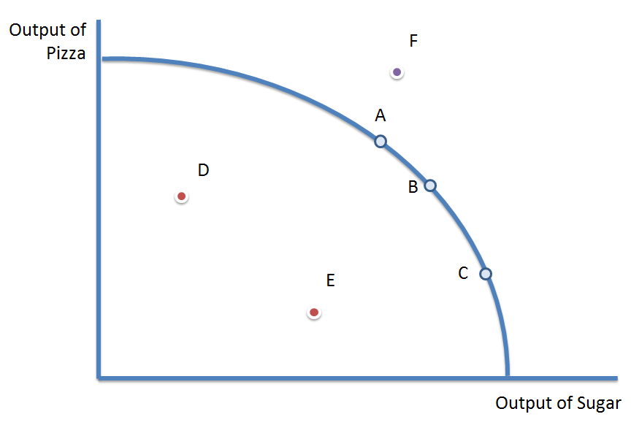
Which letter/letters apply | Description
 | Inefficient output combinations – i.e. not all resources fully utilized
 | Output combination that is not yet attainable as it lies beyond the PPF
 | Efficient output combinations as they lie on the existing PPF
Q3
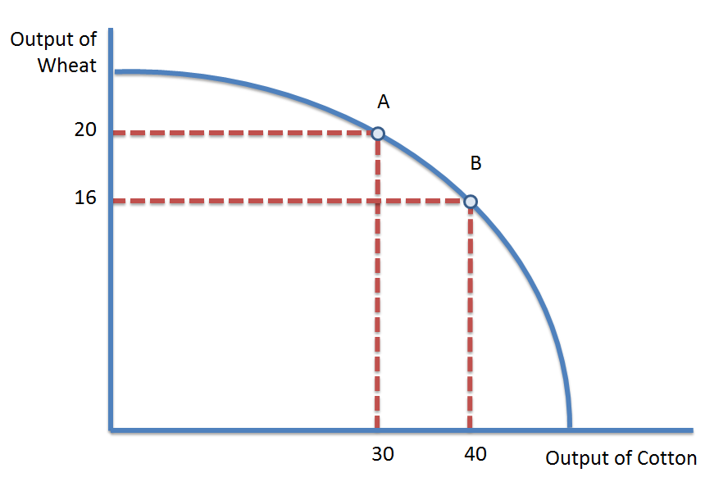

Calculate the opportunity cost of producing one more unit of cotton

Calculate the opportunity cost of producing one more unit of wheat

Q4
Explain two factors which could cause a shift out of the PPF to PPF2. (A clue is the Dubai economy)
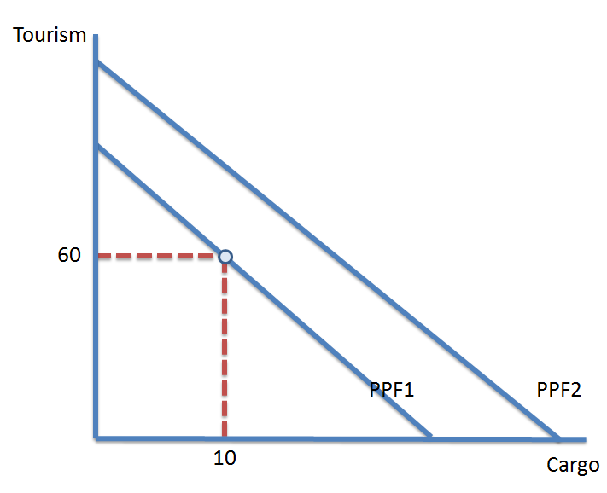

Enrichment tasks:

- Provide a summary of what Adam Smith and Hayek contributed to micro economics
Adam Smith

Hayek:

Theme 2 Macro Economics

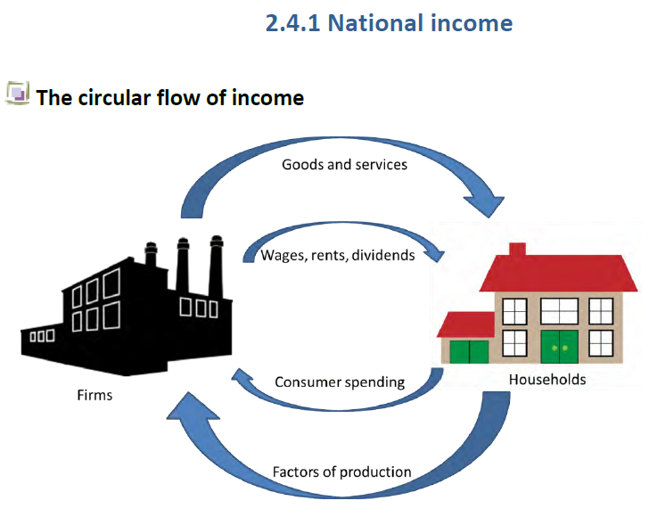
Firms and households interact and exchange resources in an economy. Households
supply firms with the factors of production, such as labour, land, capital and
enterprise, and in return, they receive wages, rent, dividends and profit.
Firms supply goods and services to households. Consumers pay firms for these.
This spending and income circulates around the economy in the circular flow of
income, which is represented in the diagram above. Therefore, national income=
national output=national expenditure.
Saving income removes it from the circular flow. This is a withdrawal of income.
Investing money into the economy is an injection.
Taxes are also a withdrawal of income, whilst government spending on public and
merit goods, and welfare payments, are injections into the economy.
International trade is also included in the circular flow of income. Exports are an
injection into the economy, since goods and services are sold to foreign countries
and revenue in earned from the sale. Imports are a withdrawal from the economy,
since money leaves the country when goods and services are bought from abroad.
The economy reaches a state of equilibrium when the rate of withdrawals = the
rate of injections.

2.4.1 National income
The full circular flow of income can be derived from this:
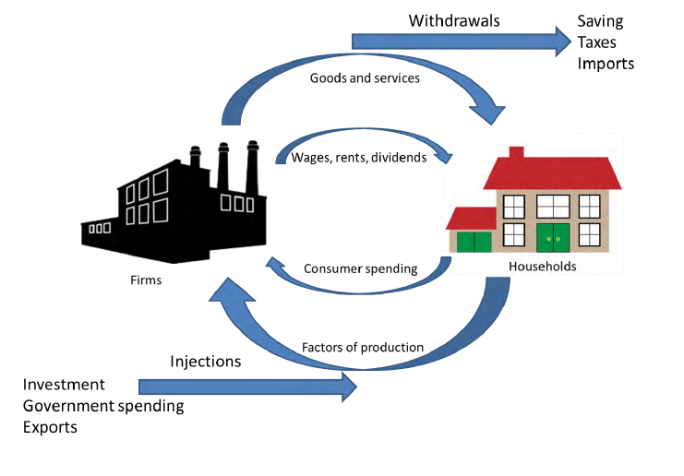
The distinction between income and wealth:
Income is a flow of money that goes to the factors of production. For example,
wages, welfare payments, profits, dividends, rents and interest are forms of income.
Wealth is a stock of assets, such as savings, shares, property, bonds and pension
Schemes
2.4.2 Injections and withdrawals
The impact of injections and withdrawals from the circular flow of
income
An injection into the circular flow of income is money which enters the economy.
This is in the form of government spending, investment and exports.
A withdrawal from the circular flow of income is money which leaves the economy.
This can be from taxes, saving and imports.
The economy reaches a state of equilibrium when the rate of withdrawals = the
rate of injections.
If there are net injections into the economy, there will be an expansion of national
output.
If there are net withdrawals from the economy, there will be a contraction of
production, so output decreases.

2.2.1 The characteristics of Aggregate Demand
2.2.1 The characteristics of Aggregate Demand
Aggregate demand (AD) is the total level of spending in the economy at any given price
Components of AD:
AD= C+I+G+(X-M)
Aggregate demand is made up of consumption (C), investment (I), government spending (G)
and net exports (X-M).
● Consumption is consumer spending on goods and services; it makes up about 60% of AD, so is the biggest part.
● Investment is spending by businesses on capital goods, such as new equipment and buildings as well as working capital e.g. stocks and work in progress; it makes up about 15-20% of AD. Most investment is by the private sector (about 75%) but there is also investment by the government.

● Government spending is spending by the government on providing goods and
services, generally public and merit goods, both on wages and salaries of public sector workers and on investment goods like new roads and schools. This will change year on year as governments decides how much they spend. Transfer payments such as pensions and jobseekers’ allowances aren’t included in the figure as money is just transferred from one group to another. Government spending tends to be around 18-20% of GDP.
● Net exports is exports minus imports: when imports are higher than exports this is a minus figure as more money leaves the UK than comes in. The UK has a large trade deficit, but this minor figure and is the least significant part of AD at around 5%.
The AD curve:
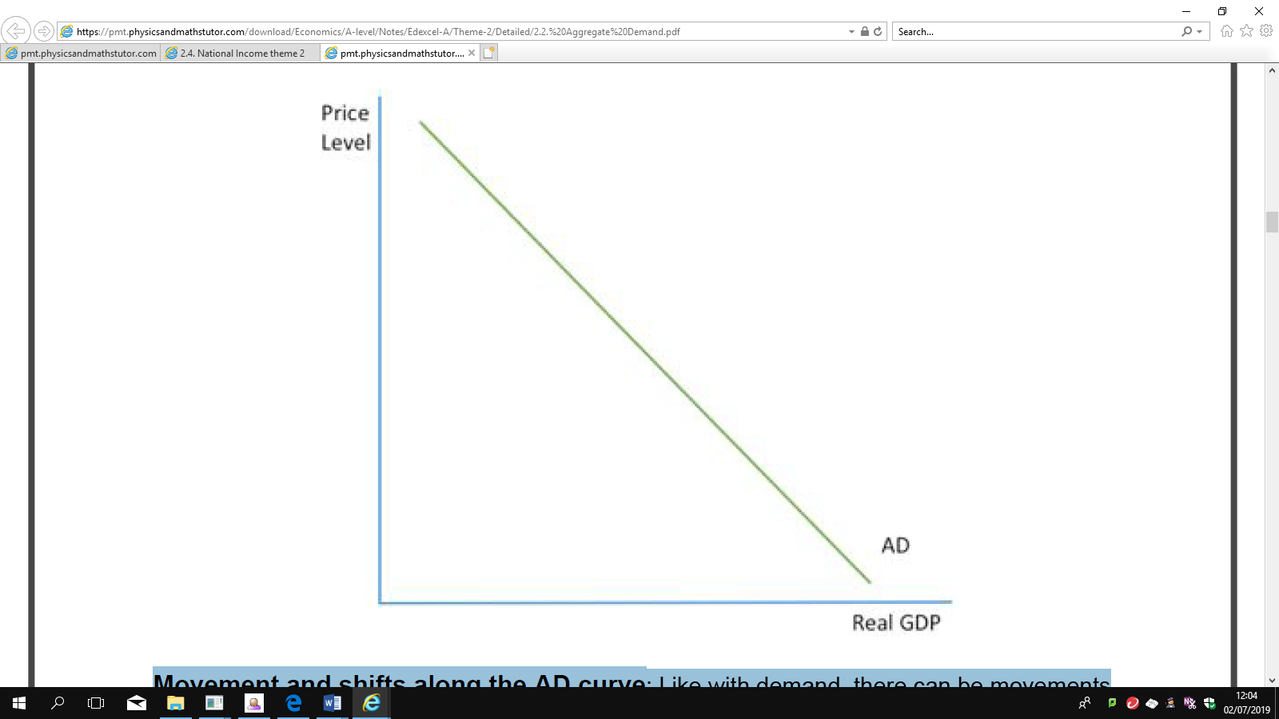

The AD curve is the same as the demand curve for an individual market, but instead of
showing the relationship between price and output, it shows the relationship between price
level and real GDP. Like the demand curve, the AD curve is downward sloping as a rise in
prices causes a fall in real GDP and there are four key reasons for this:
● Income effect: As a rise in prices is not matched straight away by a rise in income,
people have lower real incomes so can afford to buy less, leading to a contraction
demand.
● Substitution effect: If prices in the UK rise, less foreigners will want to buy British
exports and more UK residents will want to buy imported foreign goods because they
are cheaper. The rise in imports and fall of exports will decrease net exports so AD
will contract.
www.pmt.education
● Real balance effect : A rise in prices will mean that the amount people have saved
up will no longer be worth as much and so will offer less security. As a result, they will
want to save more and so reduce their spending, causing a contraction in AD.
● Interest rate effect: Rising prices mean firms have to pay their workers more and so
there is higher demand for money. If supply stays the same, then the ‘price of money’
i.e. interest rates will rise because of this higher demand. Higher interest rates mean
that more people will save and less will borrow and will also mean that businesses
invest less, so AD will contract.

Movement and shifts along the AD curve : Like with demand, there can be movements
in the AD curve or there can be shifts. A movement along the AD curve is caused by a
change in prices , caused by inflation or deflation. A shift of the AD curve is caused by a
change in any other variable . Again, as with demand, a shift to the right represents an
increase in AD and a shift to the left represents a fall in AD.
● It is important to distinguish between rates of change and absolute change: a fall in
the amount of consumption will reduce AD but a fall in the rate of rise of consumption
means that consumption is still rising so AD will still increase but by not as much.
● Some factors, for example interest rates, could cause a movement or a shift in the
AD curve. When prices increase, interest rates rise (because of the interest rate
effect) and this causes a movement along the AD curve but if the government
increases the interest rate then there is a shift in the AD curve. It is important to
always look at whether the change is because of price or not.
Questions
 | Define | Example(s)/real life data
Circular flow of income
Saving
Taxes
Imports
Government
spending
Investment
Exports
Leakages
Injections
Aggregate Demand
Income effect
Substitution
effect
Real balance effect
Interest rate
effect

CIRCULAR FLOW QUESTIONS
Q1
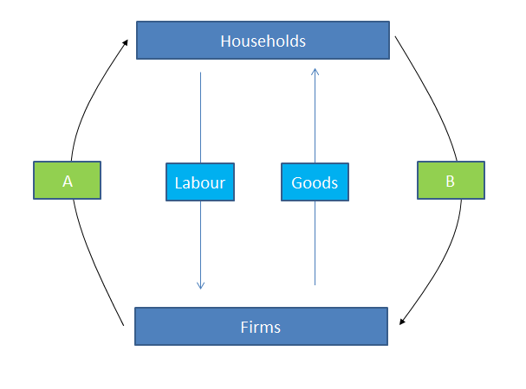
On the circular flow diagram above, what are:
A ……………………………………………………………. and B ……………………………………………………………
Q2
“When an economy is in equilibrium, then injections into the circular flow should equal withdrawals from the circular flow. Using the options below, annotate the circular flow diagram by deciding whether the words below and injections and withdrawals.
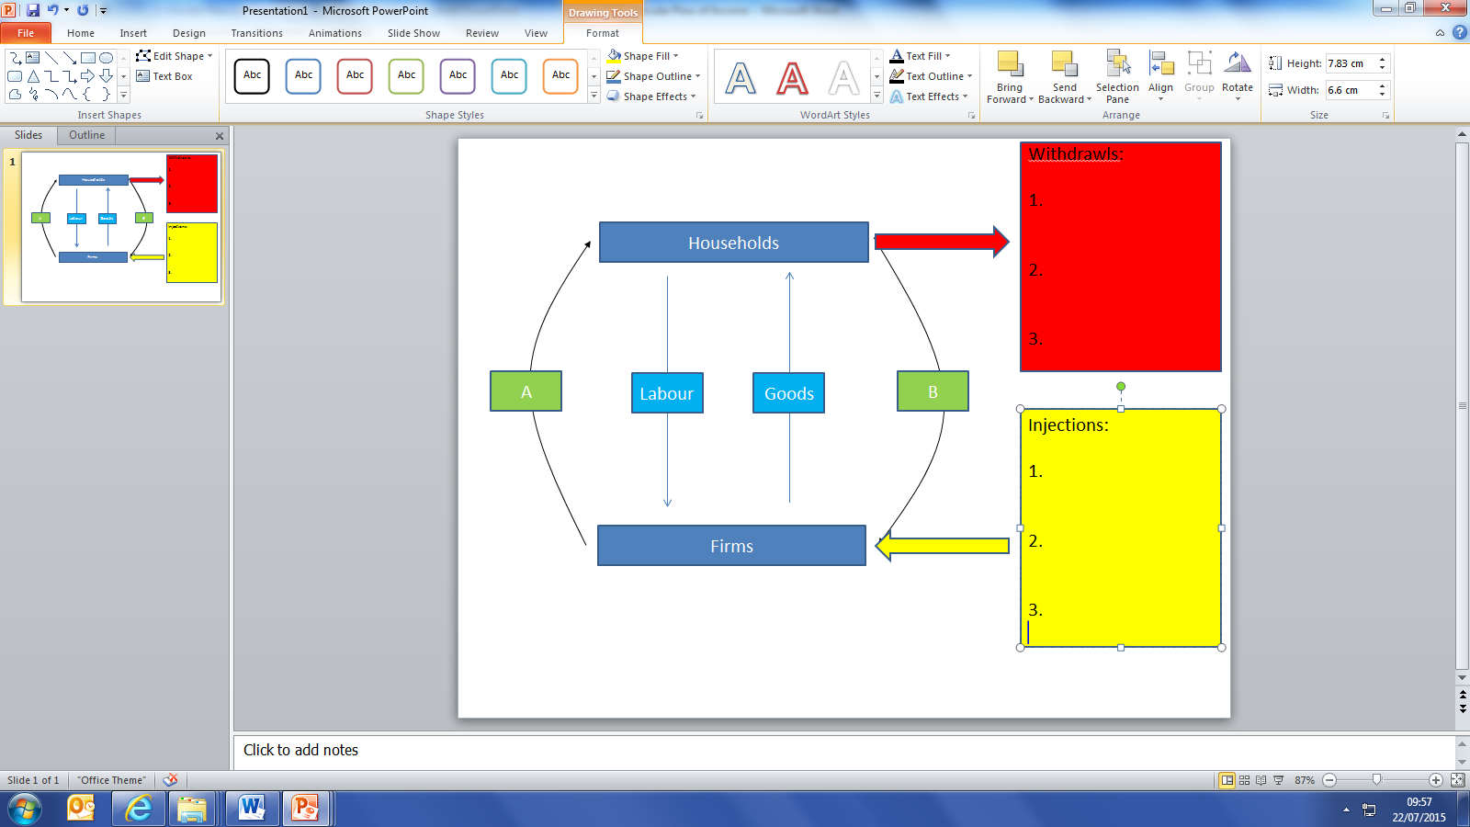
Government Spending, Investment, Savings, Import, Export, Taxation
Q3
Given what you have done so far, can you write the equation to show national income equilibrium using symbols and letters (you will need to work out which is which)! below? There are 2 ‘red herrings’ thrown in to make you think!
…………………………………………………………………………………………………………………………………………………………..
+ - = I X M S T G

Q4
True or False….read carefully!
If the sum of all injections is greater than the sum of all withdrawals then national income will rise and the economy should grow.

If the saving equals investment and exports exceed imports then national income will fall and the economy will shrink

If saving plus government spending equal taxation plus investment then the economy is in equilibrium

Q5
Using what you have learned so far and the data below, perform the calculations below.
Taxation | $100m
Imports | $60m
Government Spending | $105m
Saving | $59m
Exports | $74m
Investment | $90m

Injections = ………………………………………………………..
Withdrawals = ……………………………………………………..
Injections – Withdrawals = ………………………………………………...
AGGREGATE DEMAND
Q1
Define Aggregate Demand:
Using either +, – or brackets , fill in the gaps to create the equation used to calculate Aggregate Demand:
C I G X M
Calculate the Aggregate Demand for a country if it has the following recorded data for last year (in £bn):
Consumption | 2004000
Government consumption | 300
Investment | 220
Exports | 360
Imports | 410

Q2
Fill in the empty boxes to complete the definition of each component of AD. Remember – be precise
Component | Definition
C
I
G
X
M
Q3 Using at least 2 links, briefly explain what should happen to Aggregate Demand if:
- There is a rise in consumer confidence | Link 1:
 | Link 2:
 | So AD should:
- There is a fall in corporate profits | Link 1:
 | Link 2:
 | So AD should:
- There is a rise in the UK’s international competitiveness | Link 1:
 | Link 2:
 | So AD should:
Q4
Fill in the gaps using the words below. You can use some twice. Some may not be needed!!:
“In the UK, approximately 2/3 of Aggregate Demand comes from …………………………………………… Economists are agreed that government should seek to ……………………………………… the share of Aggregate Demand accounted for by ……………………………….. and …………………………………………………. in order to rebalance the economy. Ideally, the UK would emulate……………………………………… which has a …………………………… share of Aggregate Demand accounted for by …………………………………and …………………………… .
Choose from: government spending, exports, consumption, savings, GDP, investment, reduce, increase, larger, smaller, Germany
Q5
True or false? In a global recession…………………..
UK consumption should increase
UK investment should increase
UK government spending should decrease
UK exports should increase
UK imports should decrease

Reading Task: Read the chapter at the end of this booklet & answer the following questions.
Questions based on the reading:
- Why is Adam Smith important and what were his contributions to economics?
- Provide a summary of the three most interesting things you learnt from reading this
- What were Adam Smith’s attitude to the role of the government in policy making?
- How has the UK economy changed according to Linda?
- Having read this chapter, what else would you like to know?

