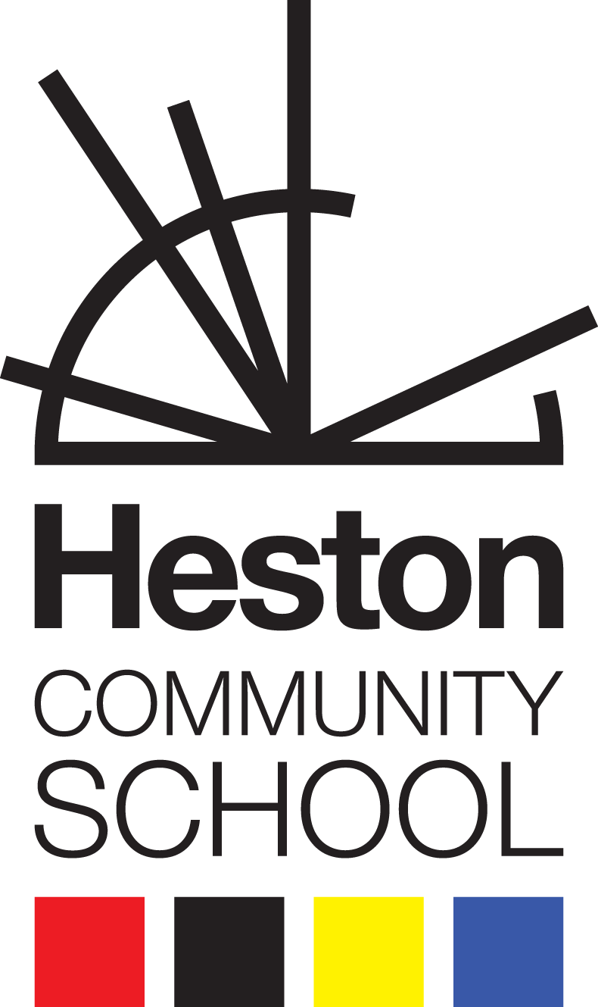
BTEC Business
Induction Pack Summer 2026

Research the different types of bank accounts and provide the details below
Type of current account | Advantages | Disadvantages
Standard | 1.  2.  3. | 1.  2.  3.
Packaged, premium | 1.  2.  3. | 1.  2.  3.
Basic | 1.  2.  3. | 1.  2.  3.
Student | 1.  2.  3. | 1.  2.  3.

Method of payment | Explanation/features | Advantages | Disadvantages
CASH |  | 1.  2.  3. | 1.  2.  3.
DEBIT CARD |  | 1.  2.  3. | 1.  2.  3.
CREDIT CARD |  | 1.  2.  3. | 1.  2.  3.
CHEQUE |  | 1.  2.  3. | 1.  2.  3.
ELECTRONIC TRANSFER |  | 1.  2.  3. | 1.  2.  3.
DIRECT DEBIT |  | 1.  2.  3. | 1.  2.  3.
ELECTRONIC TRANSFER |  | 1.  2.  3. | 1.  2.  3.

What is the difference between savings and investments
Savings are ______________________________________________________________
_________________________________________________________________________________________________________________________________________________________________________________________________________________________________
Investments are __________________________________________________________
_________________________________________________________________________________________________________________________________________________________________________________________________________________________________
Explain the Risk and Reward of savings and investment
 | Risks | Rewards
Saving

Investment

Explain the terms expenditure and shareholder
Expenditure means_______________________________________________________
_________________________________________________________________________________________________________________________________________________________________________________________________________________________________

A shareholder is __________________________________________________________
_________________________________________________________________________________________________________________________________________________________________________________________________________________________________
Different types of insurance

Type of Insurance | Advantages | Disadvantages
Car | 1.  2.  3. | 1.  2.  3.
Home and Contents | 1.  2.  3. | 1.  2.  3.
Travel | 1.  2.  3. | 1.  2.  3.
Pet | 1.  2.  3. | 1.  2.  3.
Health | 1.  2.  3. | 1.  2.  3.
Life assurance and insurance | 1.  2.  3. | 1.  2.  3.

