

BTEC AAQ INFORMATION TECHNOLOGY YEAR 12 TRANSITION BOOKLET
Contents
Overview of AAQ Information Technology 3
Outline of course 3
Year 12 BTEC IT (AAQ) – Unit 1: Information Technology Systems 4
Part 1: Understanding IT Systems 4
Part 2: IT Systems in Organisations 5
Part 3: IT System Security and Data Management 6
Part 4: Reflective Practice 7
Year 12 BTEC IT (AAQ) – Unit 3: Website Development 8
Part 1: Research and Define Key Website Development Terms 8
Part 2: Website Planning and Structure 8
Part 3: Basic HTML Practice CHALLENGE 9
Part 4: CSS Introduction 10
Part 5: Website Evaluation 10

Overview of AAQ Information Technology
The Pearson Level 3 Alternative Academic Qualification (AAQ) BTEC National in Information Technology (Extended Certificate) allows students to study the fundamental knowledge of Information Technology covering the role and implications of using Information Technology systems and cyber-security threats and how to manage attacks. Students will also develop important skills for creating websites to meet a specific purpose and to manage data through the development of a relational database solution. There are two examined units and two internally assessed units where students will engage in practical tasks to develop their Information Technology skills and knowledge. The qualification is designed to be taken alongside A Levels as part of a study programme and can link to learning in A Level Mathematics and A Level Business Studies. It is intended for students that wish to progress into higher education as a pathway to employment.

Outline of course
Mandatory Units – all students will complete the following units
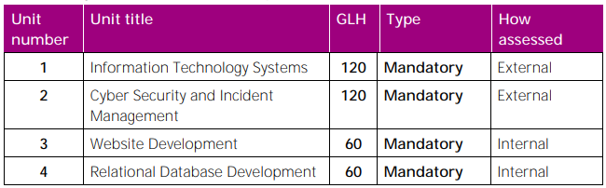
Year 1 | Year 2
Unit 1 Information Technology Systems | Unit 2 Cyber Security and Incident Management
Unit 3 Website Development | Unit 4 Rational Database Development

Holiday Assignment (Due: First Week Back)

Year 12 BTEC IT (AAQ) – Unit 1: Information Technology Systems
Objective: To reinforce understanding of IT systems, their components, and their applications in real-world scenarios.

Part 1: Understanding IT Systems
Digital Devices Overview:
  - Task: Create a table listing at least five different digital devices (e.g., desktop computers, smartphones, tablets, servers, embedded systems).
  - For each device, include:
    - Purpose: What is it used for?
    - Key Components: Main hardware and software.
    - Typical Users: Who uses this device? (e.g., businesses, consumers, educational institutions).
Digital Devices | Descriptions
Software Types and Functions:
  - Task: Write a short paragraph (100-150 words) explaining the difference between system software and application software.
  - Include examples of each and describe their roles in the operation of IT systems.

Part 2: IT Systems in Organisations
IT Systems in Business:
  - Task: Research and select a business (e.g., retail, healthcare, education).
  - Write a report (200-250 words) covering:
    - IT Systems Used: What types of IT systems does the business employ?
    - Functions: What are the primary functions of these systems?
    - Benefits: How do these systems benefit the business operations?
    - Challenges: What challenges might the business face with these IT systems?
Emerging Technologies:
  - Task: Choose an emerging technology (e.g., artificial intelligence, blockchain, Internet of Things).
  - Create a presentation (5-7 slides) addressing:
    - Overview: What is the technology?
    - Applications: How is it being used in various sectors?
    - Implications: What are the potential benefits and risks associated with this technology?

Part 3: IT System Security and Data Management
Data Security Measures:
  - Task: List and describe five common data security measures (e.g., encryption, firewalls, multi-factor authentication).
  - For each measure, explain:
    - Purpose: What does it protect against?
    - Implementation: How is it typically implemented?
    - Importance: Why is it crucial for IT systems?
Security Measures | Description

Data Accuracy and Validation:
  - Task: Write a short essay (150-200 words) discussing the importance of data accuracy in IT systems.
  - Include:
    - Consequences: What can happen if data is inaccurate?
    - Validation Techniques: How can data accuracy be ensured?
    - Real-World Example: Provide an example where data accuracy was critical.

Part 4: Reflective Practice
- Personal IT System Reflection:
  - Task: Reflect on the IT systems you use daily (e.g., smartphone, computer, online services).
  - Write a reflection (200-250 words) covering:
    - Usage: How do you use these systems?
    - Benefits: What benefits do they provide?
    - Improvements: What improvements would you suggest for these systems?

Year 12 BTEC IT (AAQ) – Unit 3: Website Development
Objective: To build foundational knowledge and skills in website development, including planning, design, and basic coding.

Part 1: Research and Define Key Website Development Terms
Write short definitions (2-3 sentences) and examples for the following terms:
- HTML –
- CSS -
- JavaScript -
- Responsive Design -
- Web Hosting -
- Domain Name -
- Client-side vs Server-side -

Part 2: Website Planning and Structure

How to create a simple website using HTML:

Step 1: Go to the W3Schools Website
- Open your browser and go to https://www.w3schools.com.
- Use the search bar to look up "HTML Tutorial" or click on the "Learn HTML" button on the homepage.

Step 2: Learn the Basics of HTML
- Start with the first lesson: HTML Introduction.
- Go through the tutorials in order:
  - HTML Basics
  - HTML Elements
  - HTML Headings
  - HTML Paragraphs
  - HTML Links
  - HTML Images
Each tutorial includes examples and an option to try it yourself using the built-in editor.

Step 3: Try the Online HTML Editor
- Click the green “Try it Yourself” button next to any example.
- This opens a new window where you can edit the HTML code on the left and view the results on the right.

Step 4: Create Your Own Simple Website Page
Here’s a basic example you can copy and modify:

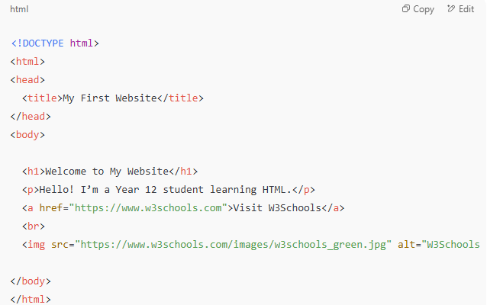
Research: Look up the basic structure of a website.
Task: Create a simple sitemap for a website about a topic of your choice (e.g., a local sports club, a restaurant, a portfolio). Printscreen your website below
- Include at least 4 pages and show how they link to each other.
c. Explain: Write a paragraph on why planning a website structure is important before development.
Screenshots here:

Part 3: Basic HTML Practice CHALLENGE
Using an online HTML editor (like W3Schools Tryit Editor), complete the following:
- Create a basic webpage with a title, heading, paragraph, and an image.
- Save a screenshot of your webpage to show your work.
Screenshots here:

Part 4: CSS Introduction
- Research what CSS is and how it works with HTML.
- Find 3 examples of CSS properties that control the appearance of text and 3 that control layout (e.g., font-size, colour, margin, padding).
- Write a short explanation for each CSS property you found.
Example 1
Example 2
Example 3
Explanation:

Part 5: Website Evaluation
Find 2 websites you use regularly and evaluate them based on the following criteria:
- Visual design (colours, layout, readability)
- Navigation (ease of finding information)
- Responsiveness (does the site work well on a phone/tablet?)
- Content (is the content clear, relevant, and well organized?)
Write a short paragraph for each website explaining what you liked and what could be improved.

Website 1 | Website 2

Paragraph:

